Name: Pranali Sonawane
Subject: CCNA
Lab – HSRP(Hot standby Router Protocol):
First, we have taken one switch, two PCs, and two routers. The PCs are connected to the switch using straight-through cables. The routers are also connected to the switch using straight-through cables.
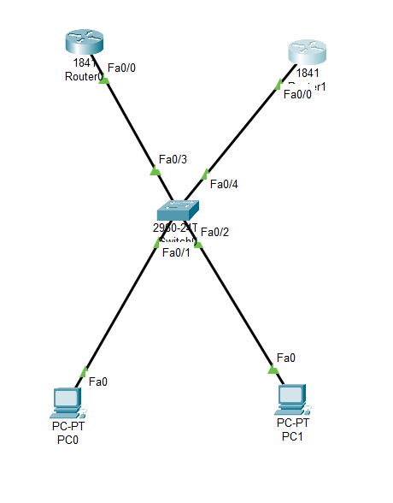
Configure PCs
- PC0:
  - IPv4 Address: 10.0.0.3
  - Subnet Mask: 255.0.0.0
  - Default Gateway: 10.0.0.10
- PC1:
  - IPv4 Address: 10.0.0.4
  - Subnet Mask: 255.0.0.0
  - Default Gateway: 10.0.0.10

Open Router 0 – CLI prompt then type following commands
Router>enable
Router#configure terminal
Router(config)# interface fastEthernet 0/0
Router(config-if)# ip address 10.0.0.1 255.0.0.0
Router(config-if)#no shutdown
Router(config-if)#standby ip 10.0.0.10
Router(config-if)#standby priority 101
Router(config-if)#standby pre-empt
Router#show standby brief
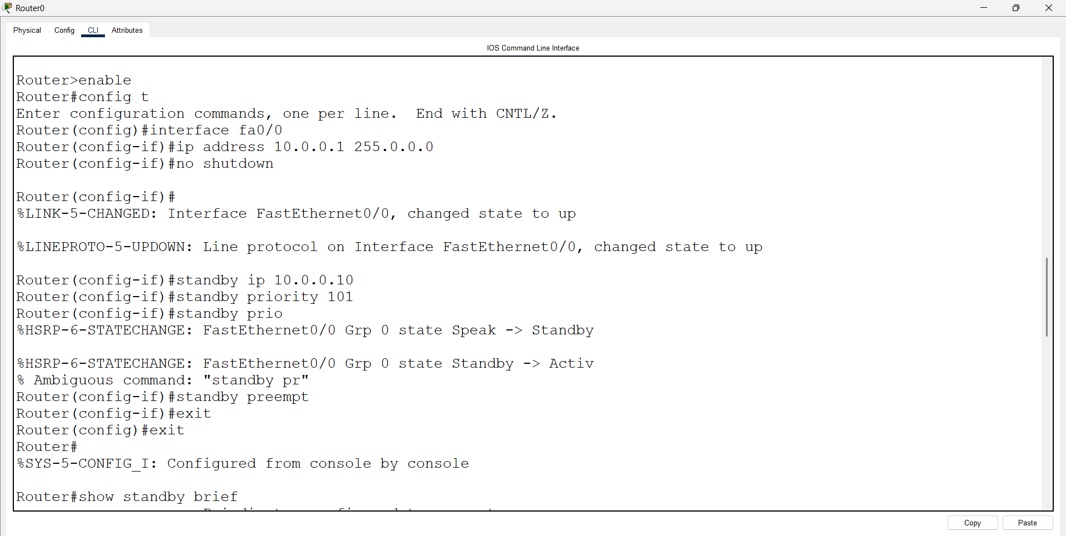
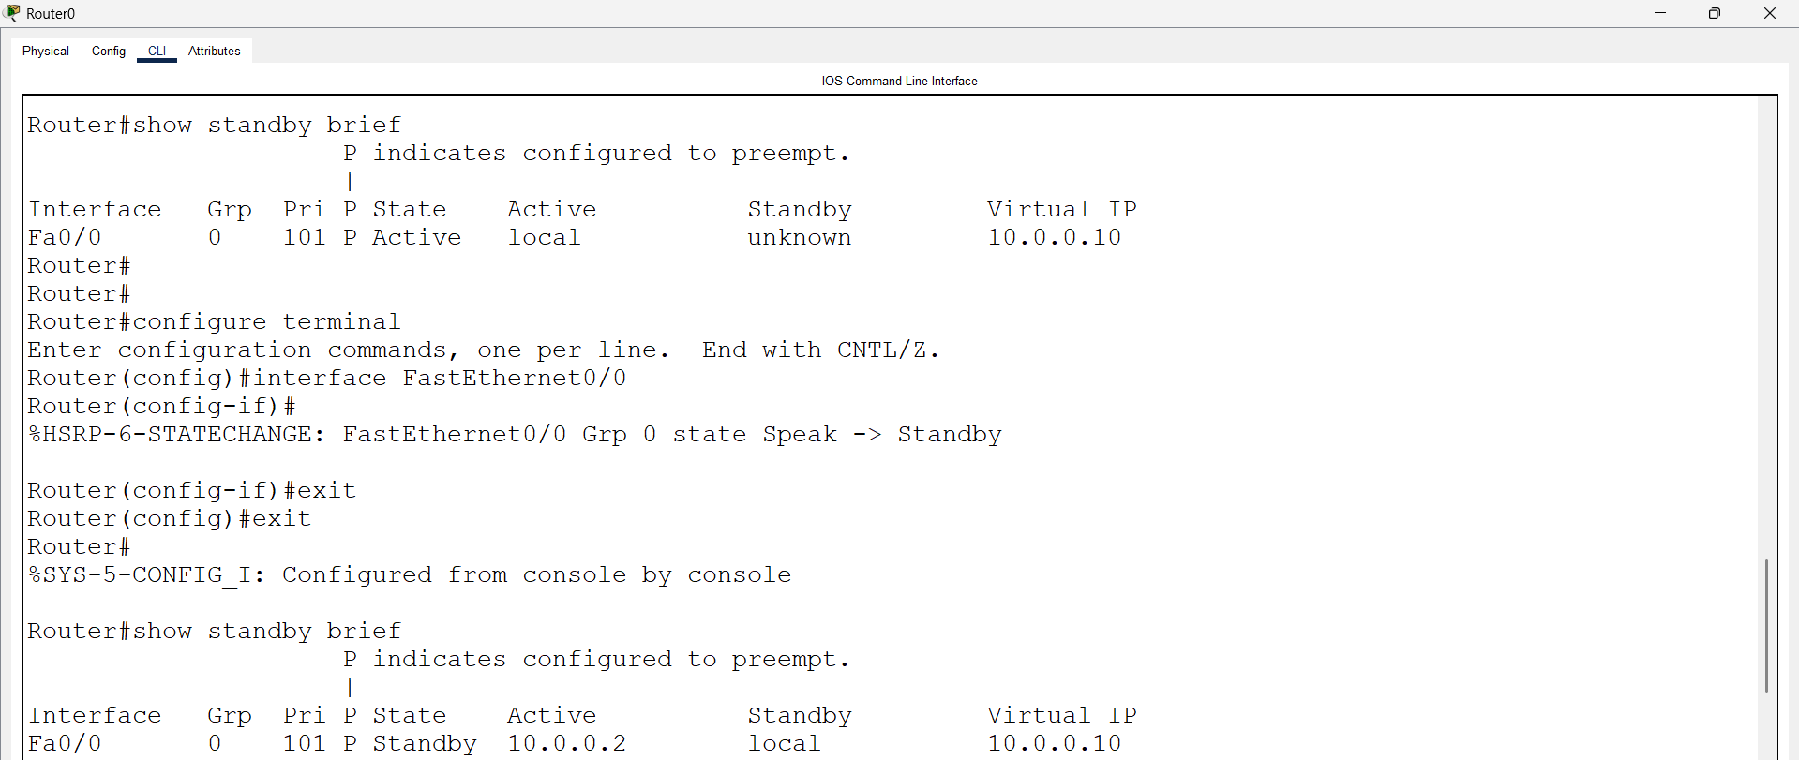
Open Router 1 – CLI prompt then type following commands
Router>enable
Router#configure terminal
Router(config)# interface fastEthernet 0/0
Router(config-if)# ip address 10.0.0.2 255.0.0.0
Router(config-if)#no shutdown
Router(config-if)#standby ip 10.0.0.10
Router(config-if)#standby priority 102
Router(config-if)#standby pre-empt
Router#show standby brief

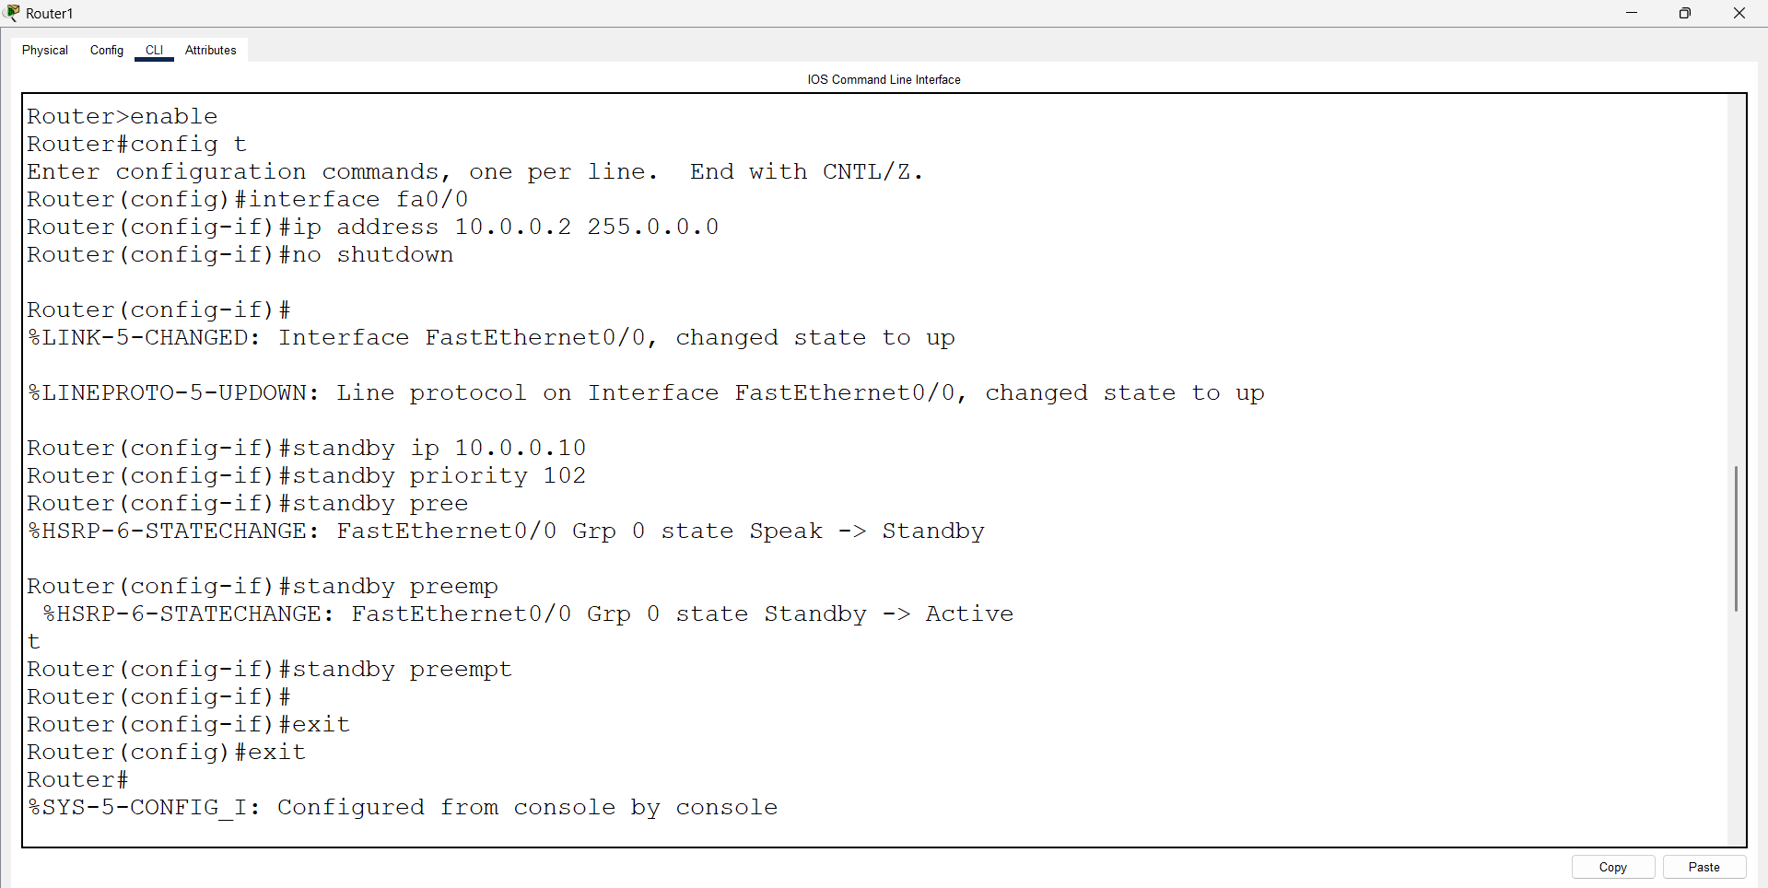

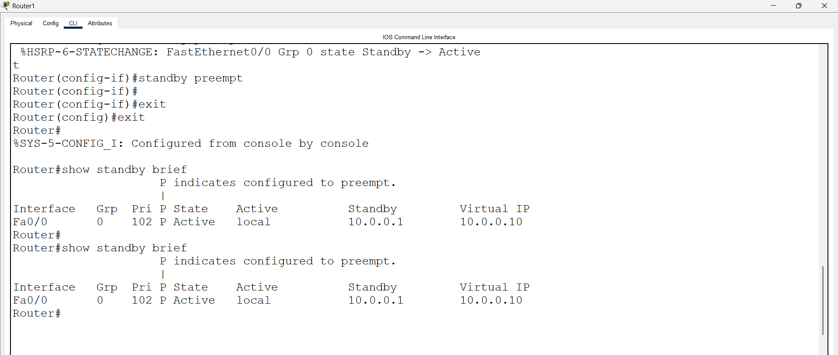
Open pc 0 – cmd prompt – type command
>ping 10.0.0.10

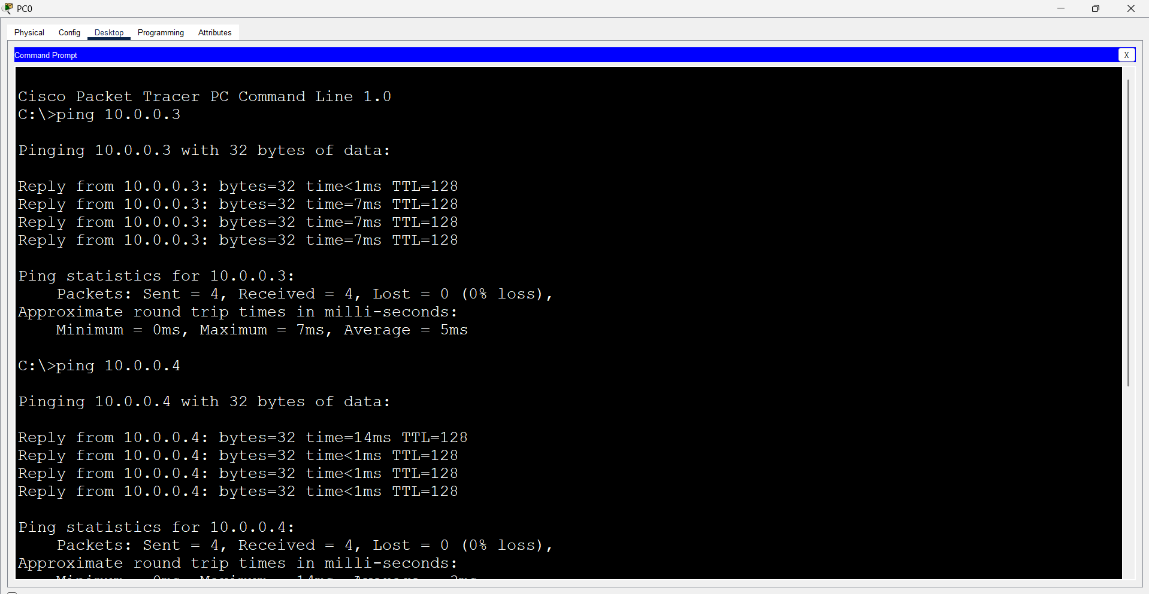

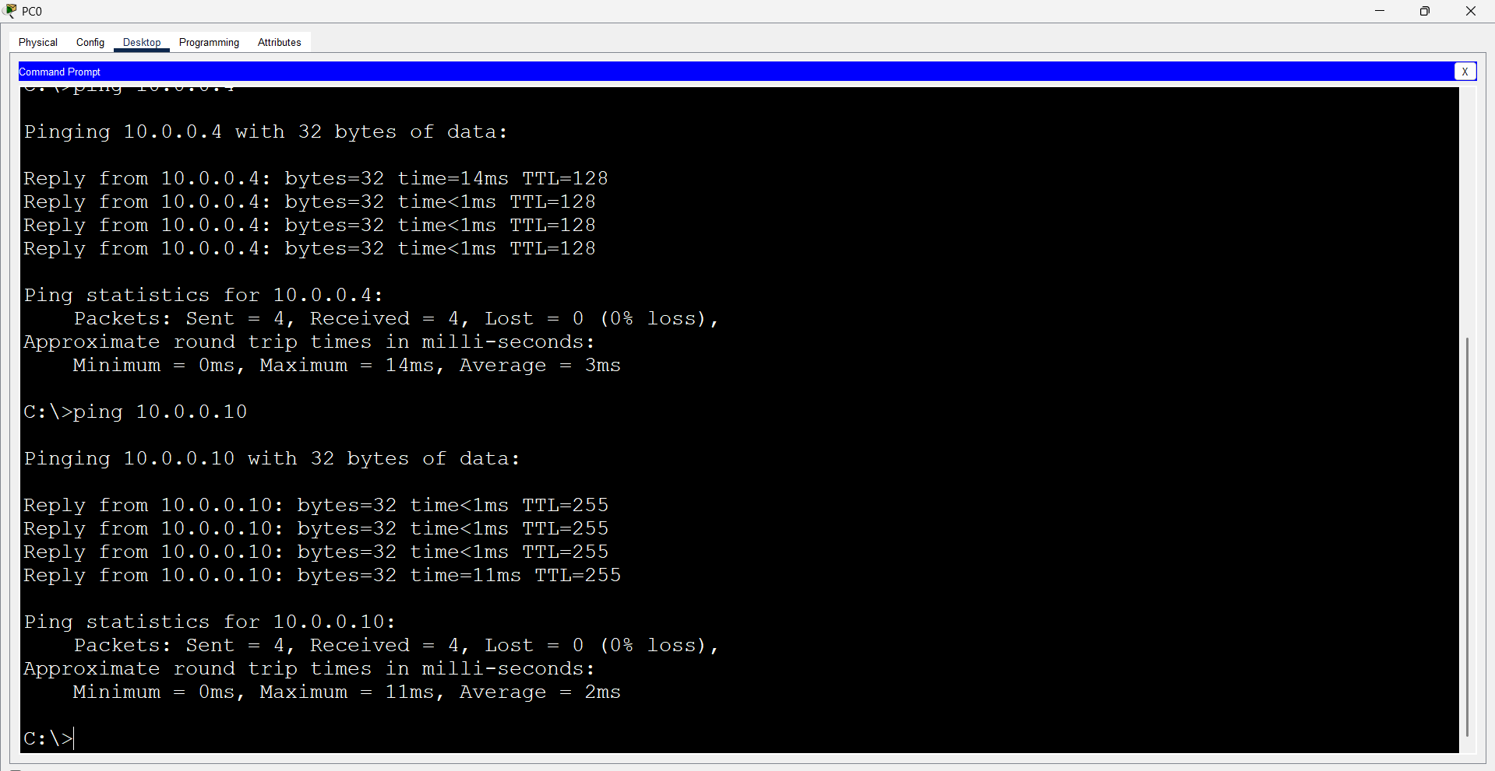

Router 0 - Initial Configuration (Interface in Shutdown State)
Router>enable
Router#configure terminal
Router(config)# interface fastEthernet 0/0
Router(config-if)# shutdown
Router#show standby brief

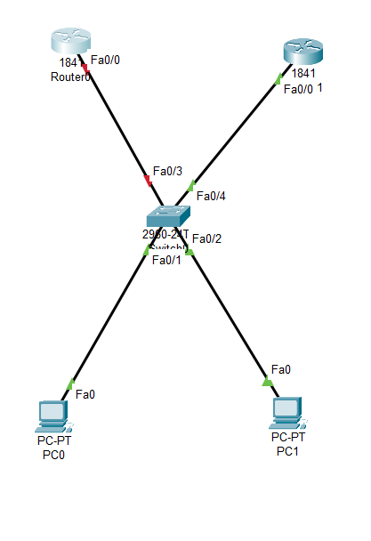
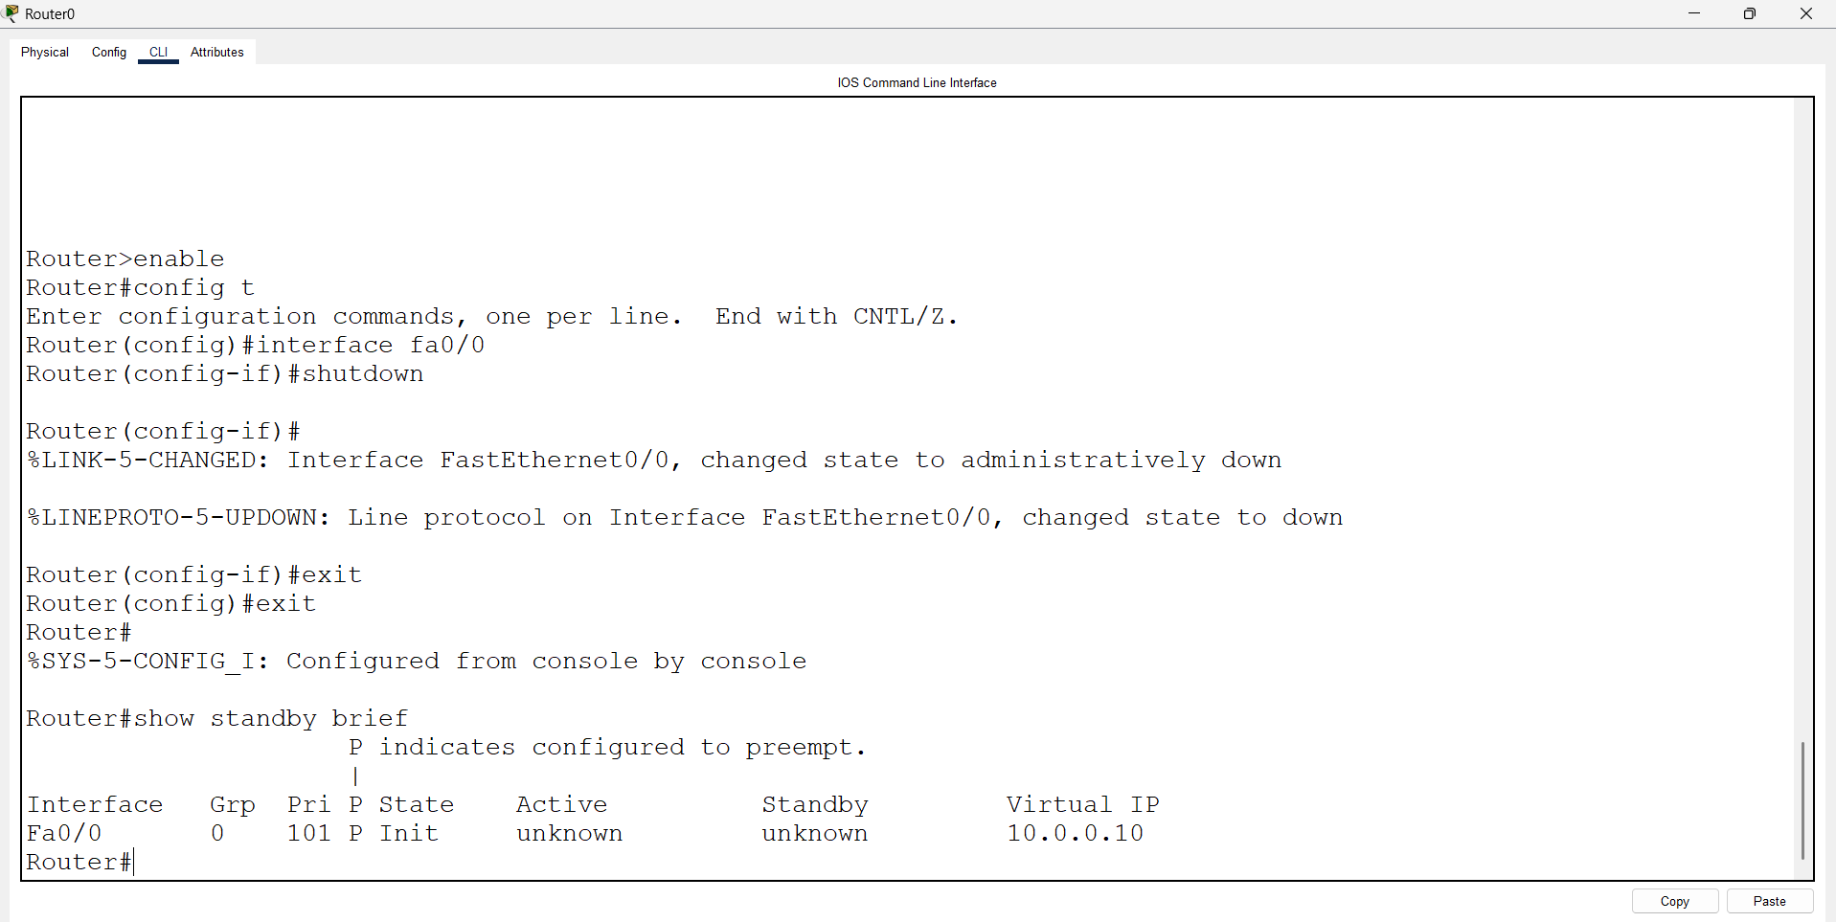

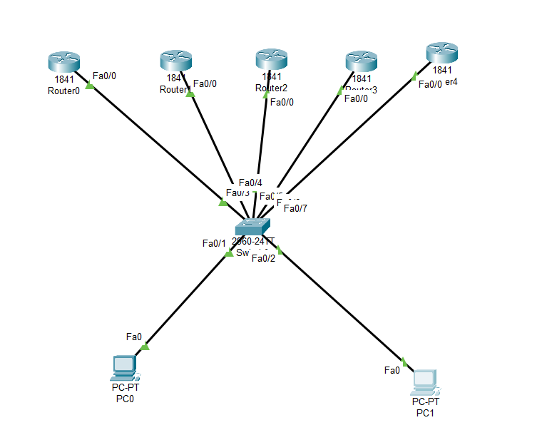
First, we have taken one switch, two PCs, and five routers. The PCs are connected to the switch using straight-through cables. The routers are also connected to the switch using straight-through cables.

Configure PCs
- PC0:
  - IPv4 Address: 10.0.0.6
  - Subnet Mask: 255.0.0.0
  - Default Gateway: 10.0.0.10
- PC1:
  - IPv4 Address: 10.0.0.7
  - Subnet Mask: 255.0.0.0
  - Default Gateway: 10.0.0.10

Open Router 0 – CLI prompt then type following commands
Router>enable
Router#configure terminal
Router(config)# interface fastEthernet 0/0
Router(config-if)# ip address 10.0.0.1 255.0.0.0
Router(config-if)#no shutdown
Router(config-if)#standby ip 10.0.0.10
Router(config-if)#standby priority 101
Router(config-if)#standby pre-empt
Router#show standby brief

Open Router 1 – CLI prompt then type following commands
Router>enable
Router#configure terminal
Router(config)# interface fastEthernet 0/0
Router(config-if)# ip address 10.0.0.2 255.0.0.0
Router(config-if)#no shutdown
Router(config-if)#standby ip 10.0.0.10
Router(config-if)#standby priority 102
Router(config-if)#standby pre-empt
Router#show standby brief
Open Router 3 – CLI prompt then type following commands
Router>enable
Router#configure terminal
Router(config)# interface fastEthernet 0/0
Router(config-if)# ip address 10.0.0.3 255.0.0.0
Router(config-if)#no shutdown
Router(config-if)#standby ip 10.0.0.10
Router(config-if)#standby priority 103
Router(config-if)#standby pre-empt
Router#show standby brief

Open Router 4 – CLI prompt then type following commands
Router>enable
Router#configure terminal
Router(config)# interface fastEthernet 0/0
Router(config-if)# ip address 10.0.0.4 255.0.0.0
Router(config-if)#no shutdown
Router(config-if)#standby ip 10.0.0.10
Router(config-if)#standby priority 104
Router(config-if)#standby pre-empt
Router#show standby brief

Open Router 5 – CLI prompt then type following commands
Router>enable
Router#configure terminal
Router(config)# interface fastEthernet 0/0
Router(config-if)# ip address 10.0.0.5 255.0.0.0
Router(config-if)#no shutdown
Router(config-if)#standby ip 10.0.0.10
Router(config-if)#standby priority 105
Router(config-if)#standby pre-empt
Router#show standby brief

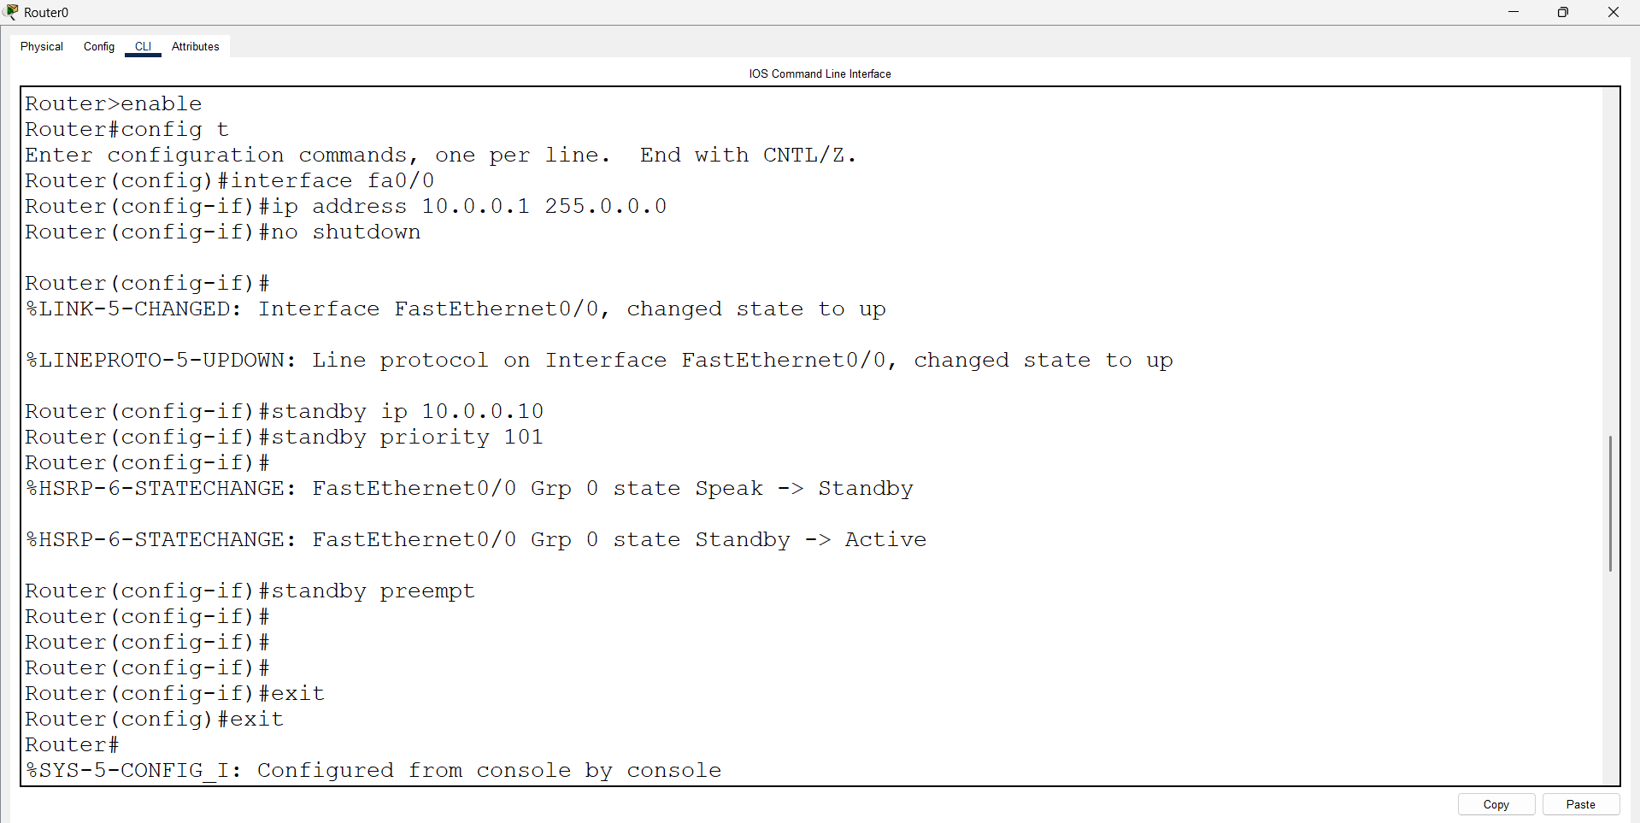
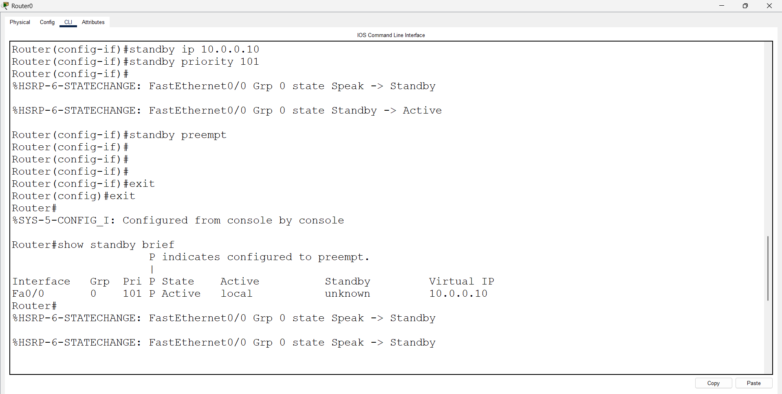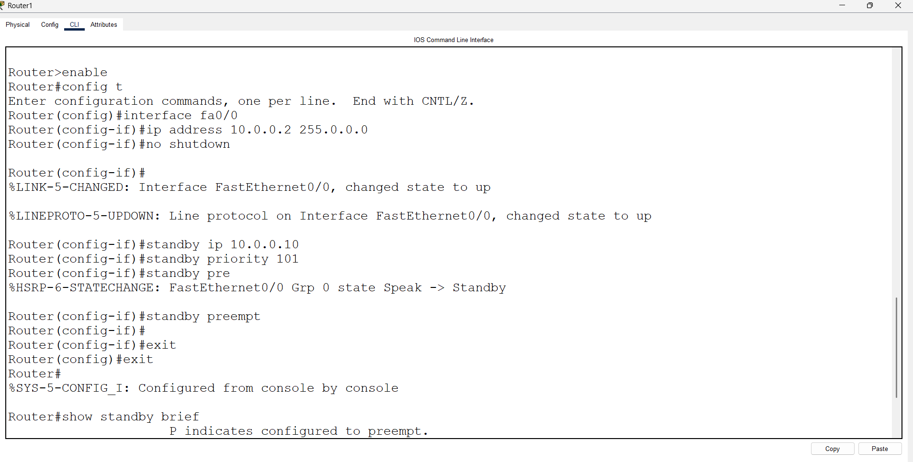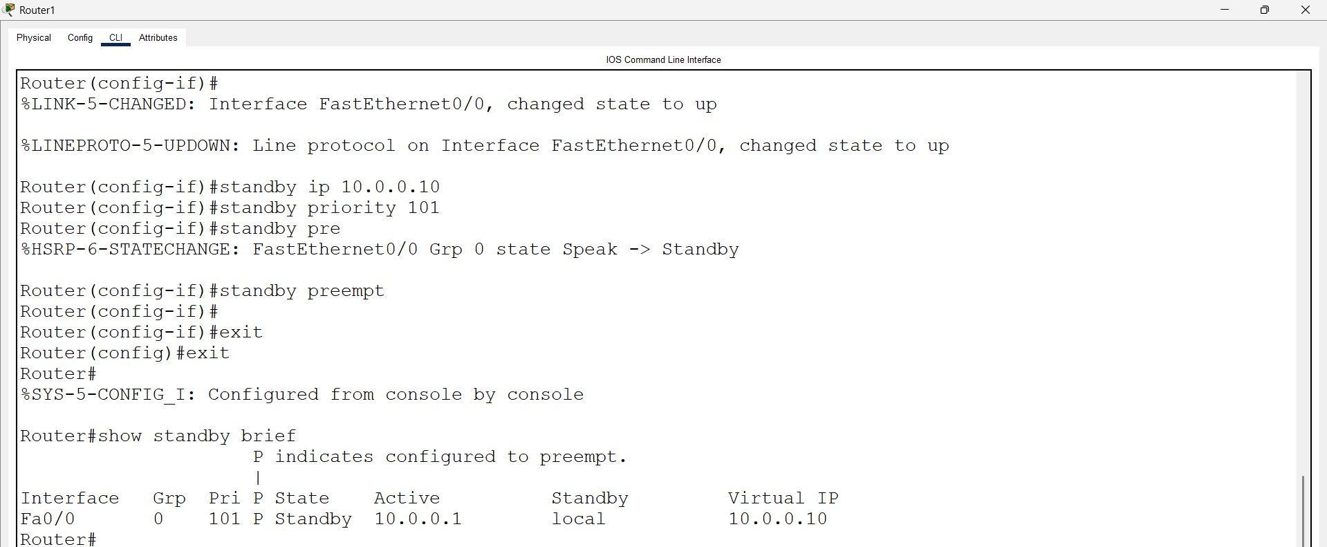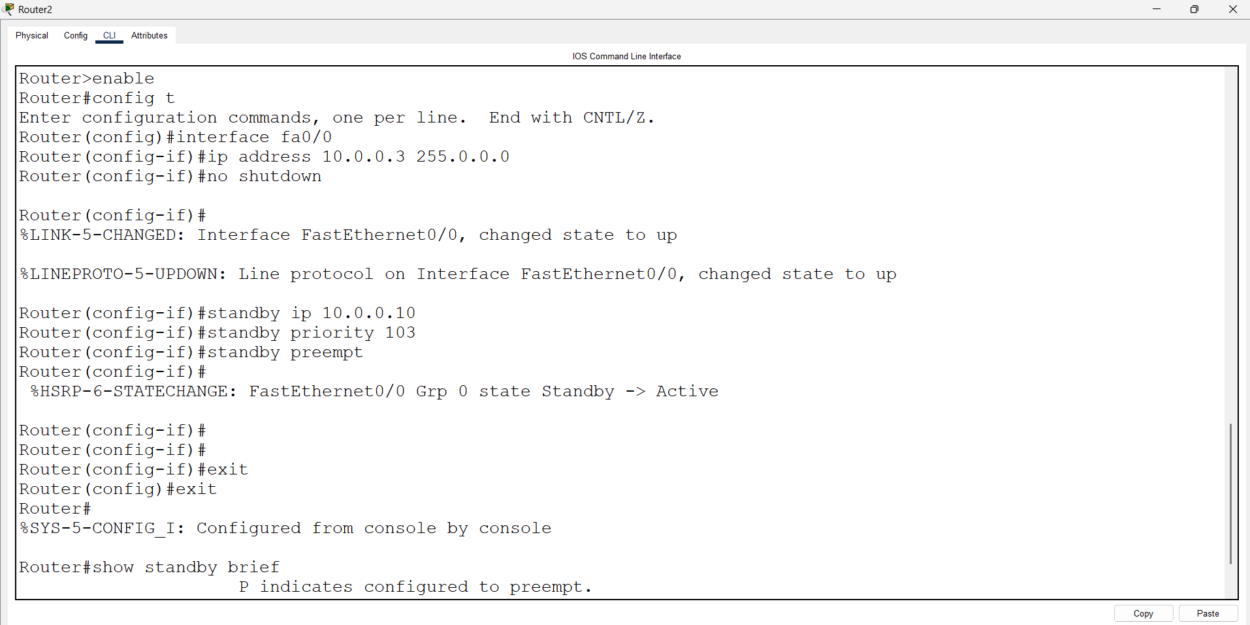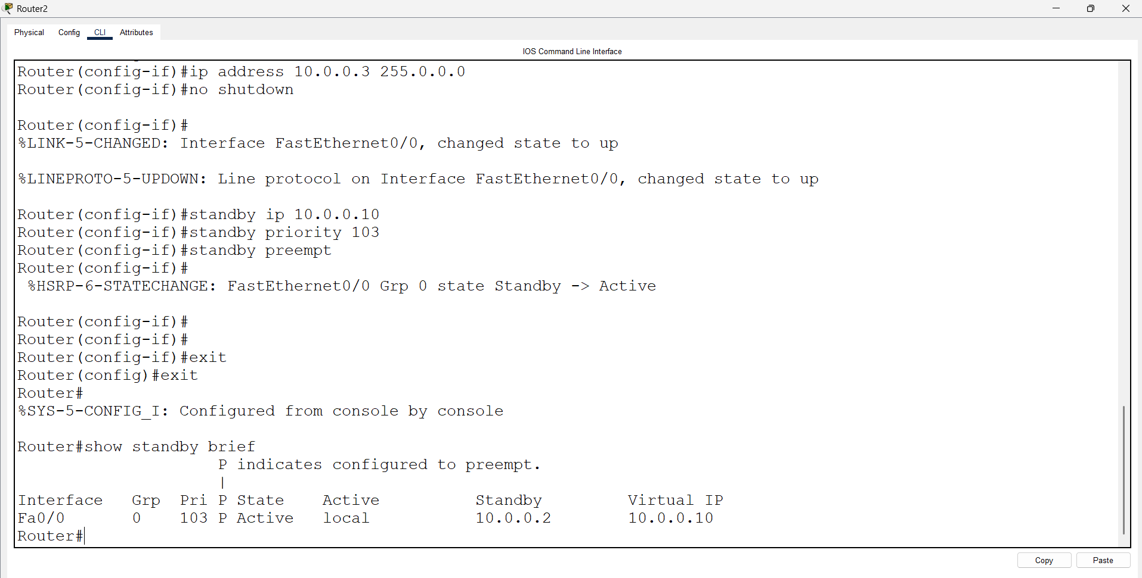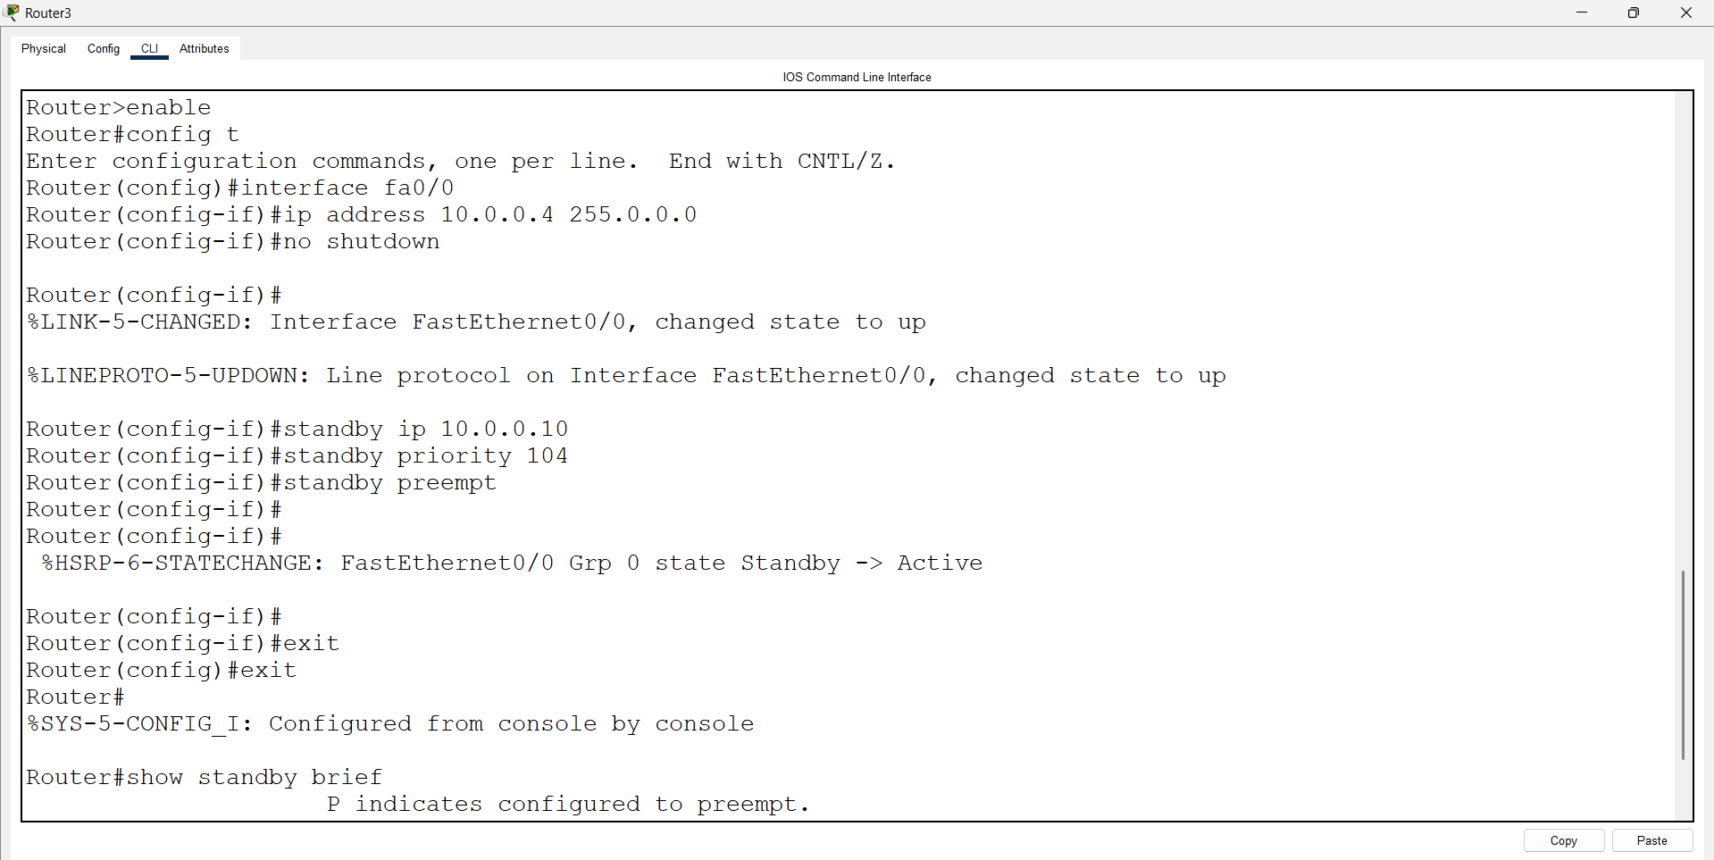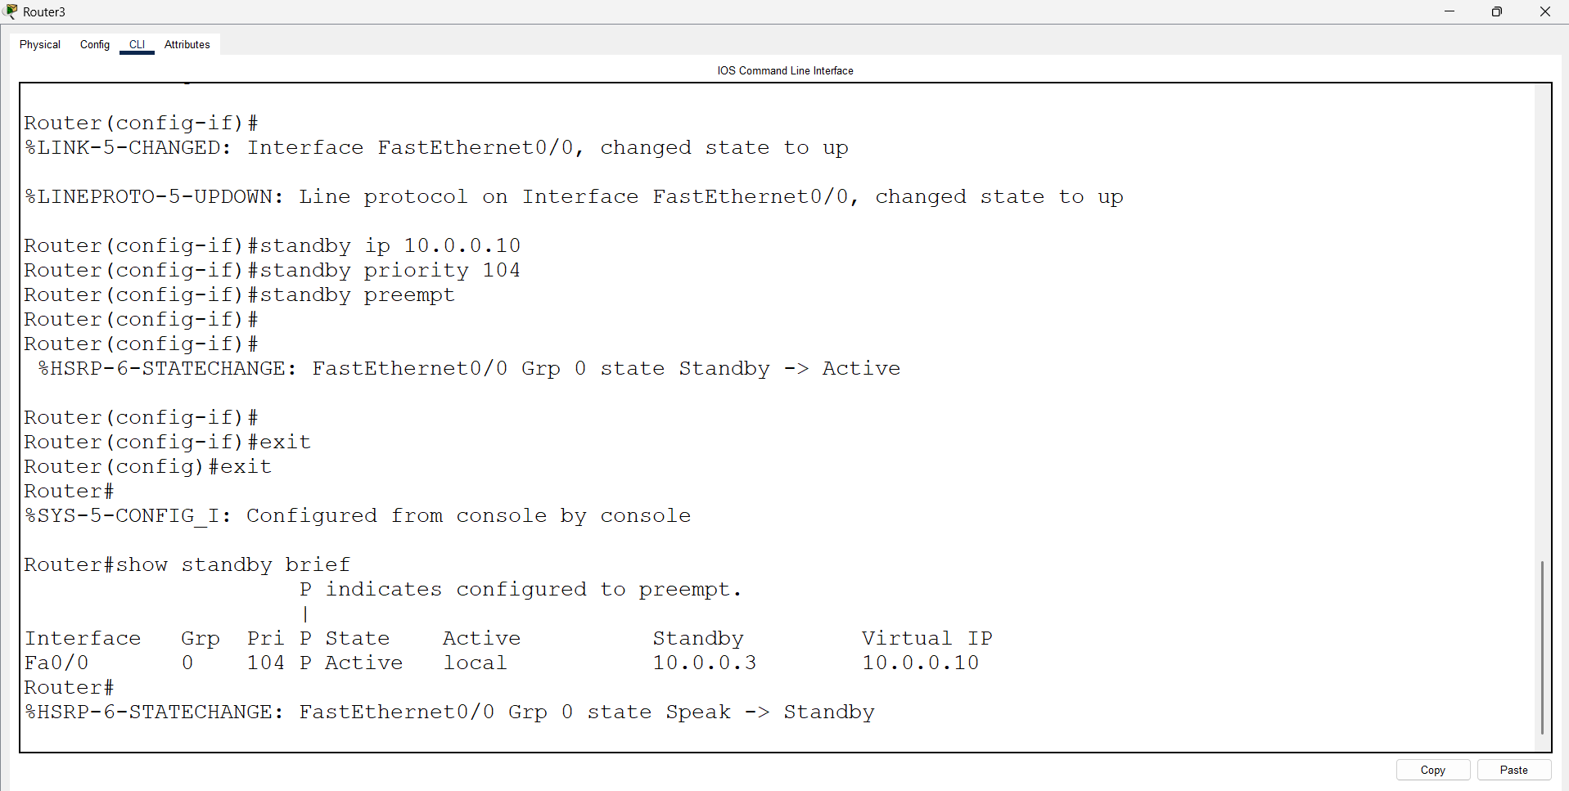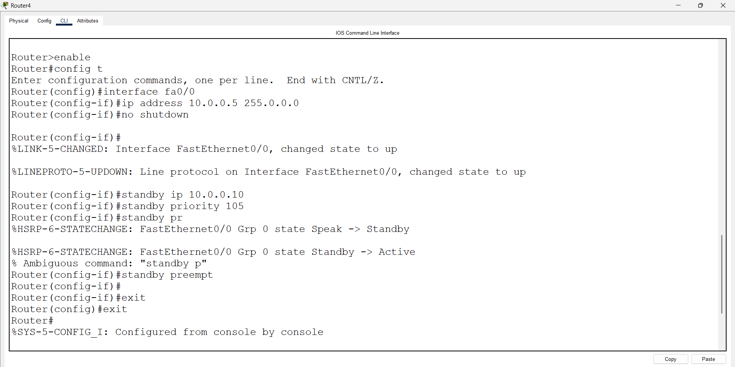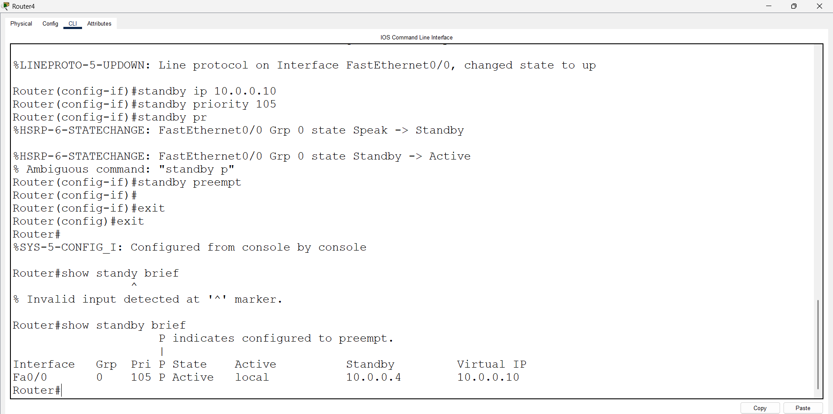
Open pc 0 – cmd prompt – type command
>ping 10.0.0.10

